**Project Design Phase-II**

**Technology Stack (Architecture & Stack)**

|  |  |
| --- | --- |
| Date | 27 June 2025 |
| Team ID | LTVIP2025TMID29382 |
| Project Name | Smart SDLC-AI-Enhanced Software Development Life Cycle |
| Maximum Marks | 4 Marks |

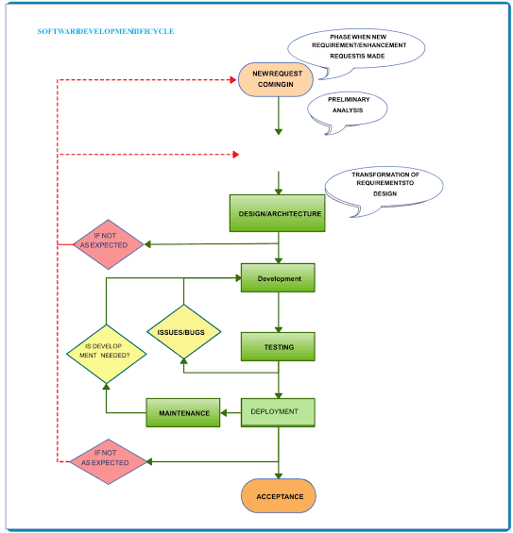**Technical Architecture:**

**Table-1 : Components & Technologies:**

|  |  |  |  |  |  |  |  |  |  |  |  |  |  |  |  |  |  |  |
| --- | --- | --- | --- | --- | --- | --- | --- | --- | --- | --- | --- | --- | --- | --- | --- | --- | --- | --- |
| |  |  |  | | --- | --- | --- | | **Components** | **Description** | **Technology** **Used** | | **Vertex AI (Google Cloud)** | Provides AI/LLM capabilities across all components | Google Cloud Vertex AI / Gemini | | **Google Cloud Run** | Hosts and runs all microservices as serverless containers | Cloud Run + Docker | | **Cloud Storage** | Stores intermediate files and chat histories | Google Cloud Storage | | **Google Secret Manager** | Stores secrets like API keys, tokens | Secret Manager | | **GitLab / GitHub** | Version control system and trigger point for workflows | GitLab/GitHub + Webhooks | |

**Table-2: Application Characteristics:**

|  |  |  |  |  |  |  |  |  |  |  |  |  |  |  |  |  |  |  |  |  |  |
| --- | --- | --- | --- | --- | --- | --- | --- | --- | --- | --- | --- | --- | --- | --- | --- | --- | --- | --- | --- | --- | --- |
| | **Characteristic** | **Description** | **Technologies Used** | | --- | --- | --- | | **Modular Architecture** | Each SDLC task is handled by a separate service (e.g., evaluator, tc-generator, etc.). | Node.js, Docker, Microservices | | **Scalability** | Auto-scales based on demand; services run independently and stateless. | Google Cloud Run, Docker | | **Documentation Automation** | Generates solution overviews, API docs, and database summaries automatically. | Vertex AI, Node.js | | **Test Automation** | Creates test scripts for multiple frameworks (Cypress, Selenium, Playwright). | Node.js, Cypress, Selenium, Playwright, Vertex AI | | **Extensibility** | Easy to add new modules or swap out components as needed. | Open API interfaces, Microservice architecture | | **Security & Secrets Management** | Manages keys, tokens, and sensitive data securely. | Google Secret Manager | |